Project Report

Freelancer Data
Freelancer | Skill | Cost per Day | Experience (Years)
Alice | Planning | 300 | 5
Bob | Data Collection | 320 | 4
Cara | Data Cleaning | 350 | 3
Dan | EDA | 330 | 4
Ella | Modeling | 400 | 6

Task Data
Task ID | Task Name | Required Skill | Duration (days) | Dependencies
T01 | Define Requirements | Planning | 2 | nan
T02 | Collect Data | Data Collection | 4 | T01
T03 | Preprocess Data | Data Cleaning | 3 | T02
T04 | EDA | EDA | 3 | T03
T05 | Train Model | Modeling | 5 | T04
T06 | Validate Model | Modeling | 2 | T05
T07 | Document Findings | Writing | 2 | T04
T08 | Create Dashboard | Visualization | 4 | T06
T09 | Prepare Report | Writing | 3 | T07,T08
T010 | Review & Submit | Review | 2 | T09

Cost Matrix
 | T1 | T2 | T3 | T4 | T5 | T6 | T7 | T8 | T9 | T10
F1 | 60.00 | 10000.00 | 10000.00 | 10000.00 | 10000.00 | 10000.00 | 10000.00 | 10000.00 | 10000.00 | 10000.00
F2 | 10000.00 | 80.00 | 10000.00 | 10000.00 | 10000.00 | 10000.00 | 10000.00 | 10000.00 | 10000.00 | 10000.00
F3 | 10000.00 | 10000.00 | 116.67 | 10000.00 | 10000.00 | 10000.00 | 10000.00 | 10000.00 | 10000.00 | 10000.00
F4 | 10000.00 | 10000.00 | 10000.00 | 82.50 | 10000.00 | 10000.00 | 10000.00 | 10000.00 | 10000.00 | 10000.00
F5 | 10000.00 | 10000.00 | 10000.00 | 10000.00 | 66.67 | 66.67 | 10000.00 | 10000.00 | 10000.00 | 10000.00

Assignments (Hungarian Method)
Freelancer | Skill | Experience | Task ID | Task Name | Cost/Day | Duration | Total Cost
Alice | Planning | 5 | T01 | Define Requirements | 300 | 2 | 600
Bob | Data Collection | 4 | T02 | Collect Data | 320 | 4 | 1280
Cara | Data Cleaning | 3 | T03 | Preprocess Data | 350 | 3 | 1050
Dan | EDA | 4 | T04 | EDA | 330 | 3 | 990
Ella | Modeling | 6 | T05 | Train Model | 400 | 5 | 2000

CPM Task Schedule
Task | Name | ES | EF | LS | LF | Slack
T01 | Define Requirements | 0 | 2 | 0 | 2 | 0
T02 | Collect Data | 2 | 6 | 2 | 6 | 0
T03 | Preprocess Data | 6 | 9 | 6 | 9 | 0
T04 | EDA | 9 | 12 | 9 | 12 | 0
T05 | Train Model | 12 | 17 | 12 | 17 | 0
T06 | Validate Model | 17 | 19 | 17 | 19 | 0
T07 | Document Findings | 12 | 14 | 21 | 23 | 9
T08 | Create Dashboard | 19 | 23 | 19 | 23 | 0
T09 | Prepare Report | 23 | 26 | 23 | 26 | 0
T010 | Review & Submit | 26 | 28 | 26 | 28 | 0

Critical Path Graph
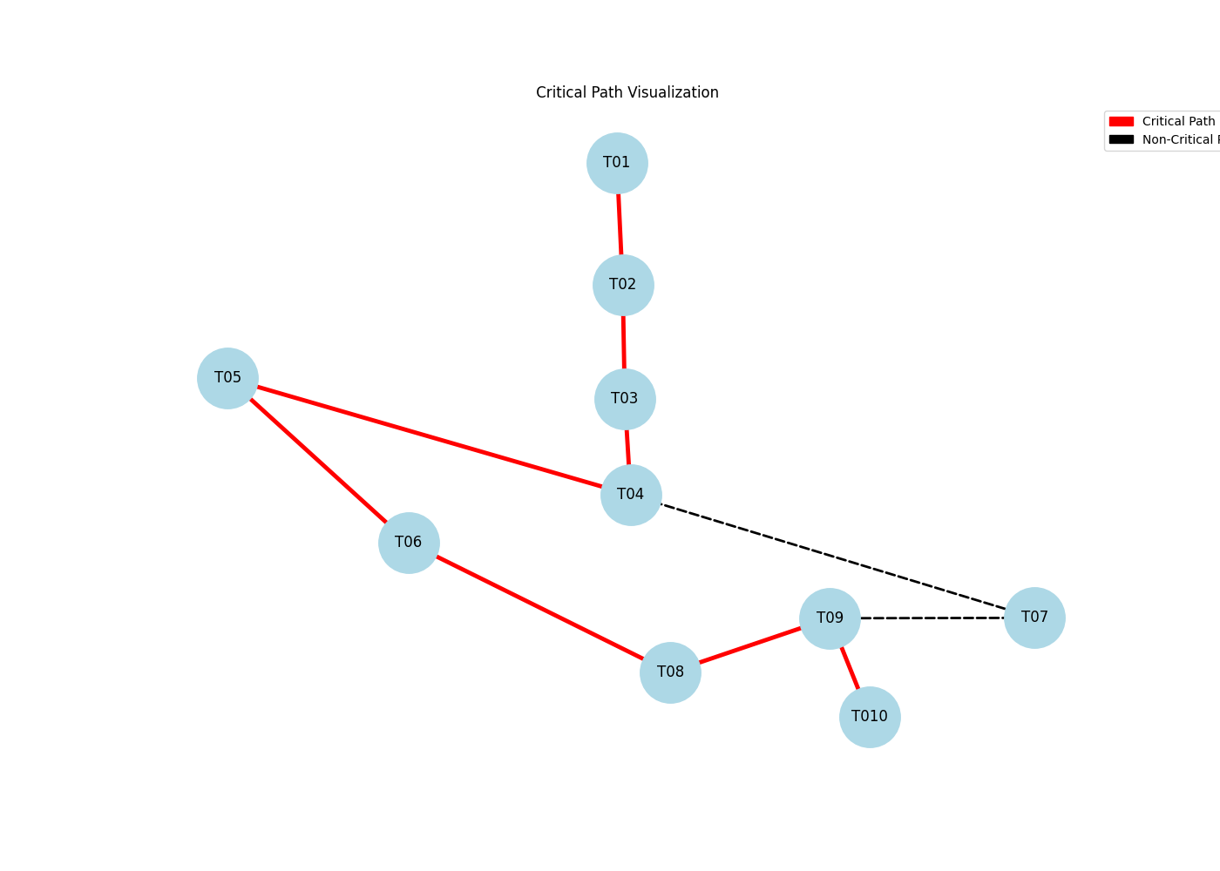

Summary
Total Assignment Cost: $5920.00
Budget Exceeded by $920.00
Critical Path: T01 → T02 → T03 → T04 → T05 → T06 → T08 → T09 → T010
Project Duration: 28 days

